Mr. Deepak Ohry,
5 Tollhouse Lane, Wallington
Surrey SM6 9PA, England
Tel. 0044(0)20 8647 4929
email dohry@aol.com

23 February 2007
Dr. D.K.Chaturvedi
Reader, Department of Electrical Engineering &
Faculty of Engineering,
Dayalbagh Educational Institute,
(Deemed University)
Dayalbagh, Agra, INDIA

Invitation to London

Dear Dr. Chaturvedi
My family and I would like to invite you to visit us in London during May 2007.

You need not worry about anything as we will be delighted to make all transport, accommodation and meal arrangements. If you can visit from May 23 -30 2007, this would be ideal.

Hope to hear from you soon.
Yours truly
,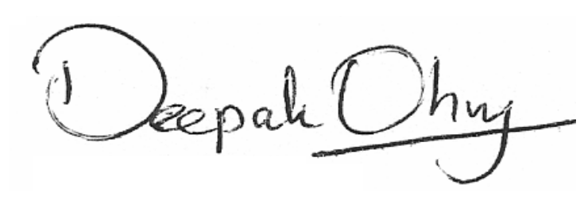
Mr. Deepak Ohry.

